


Copilot Business
Value Bootcamp
  - Case Studies

Table of Contents
Instructions 3
Case Study: Company A 4
Scenario 4
KPI analysis 4
Optional time-savings analysis 4
Case Study: Company B 5
Scenario 5
KPI analysis 5
Optional time-savings analysis 5
Case Study: Company C 6
Scenario 6
KPI analysis 6
Optional time-savings analysis 6
Case Study: Company D 7
Scenario 7
KPI analysis 7
Optional time-savings analysis 7
Questions? 8

Instructions
Below are four Microsoft 365 Copilot scenarios designed to help you become familiar with the Microsoft 365 Copilot module in the Business Case Builder (BCB).
To access the tool, please visit the BCB Homepage and download the Advanced BCB Excel file. To access the features in the BCB, please ensure to enable macros.
For further instructions on the tool, please visit the Learning page. We recommend utilizing the resources under:
- The “Copilot” section for information on the Microsoft 365 Copilot module.
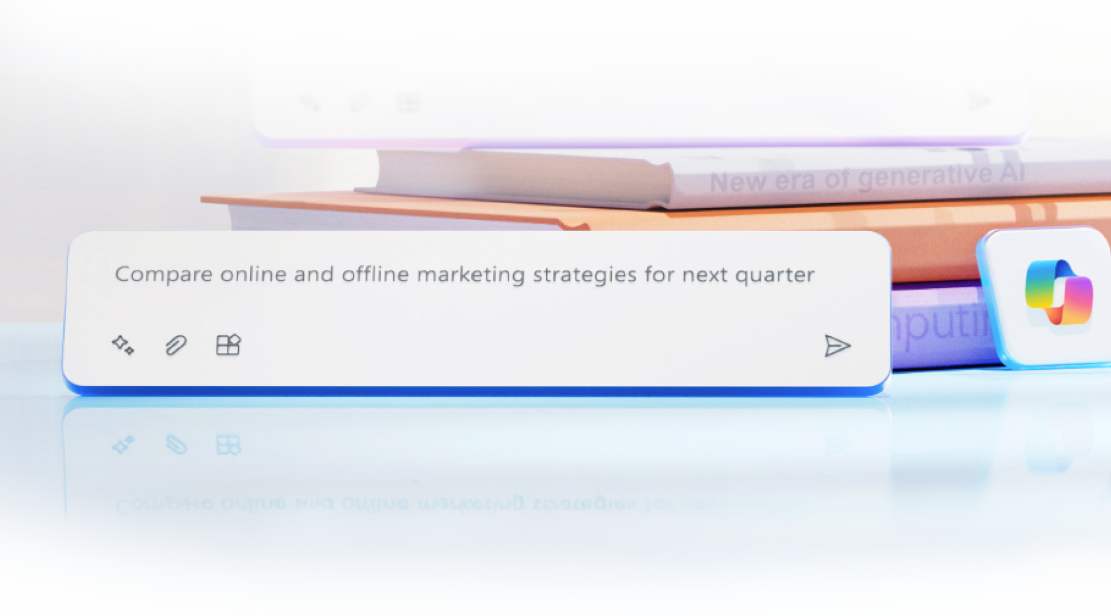
- The “Building a Business Case with the Advanced BC” section for general knowledge on the Advanced BCB.

Case Study: Company A
Company A profile – 60,000 users, Marketing/Customer Service
Company A is one of the largest wireless network carriers in the United States. Company A has 60,000 employees, as well as $30B in annual revenue and a 37% profit margin. Company A considers itself an early adopter of technology and would like to see how AI can support its business.

Scenario
Company A currently has no AI solutions but is considering building their own AI tooling. If they do choose to purchase Microsoft 365 Copilot, they plan on deploying it to 48,000 users.

KPI analysis
Note: Make sure to select the correct type of analysis under Step 3 inside the tool.
- After reviewing the time-savings benefits, Company A’s executives are interested in seeing how Microsoft 365 Copilot would specifically impact its two biggest departments’ business processes: Marketing and Customer Service. They are not interested in KPIs from any other department.
- Company A currently spends $1M to outsource some of its marketing processes to an agency, but it estimates that Copilot could bring 5% of that workload in-house.
- Company A also estimates that Copilot will improve the quality of the content the Marketing department will generate, which will result in a 0.5% increase in the number of marketing leads generated per year.
- Company A’s Customer Service department has been experiencing an increased number of calls in the last year, which Company A believes can be reduced by 20% by implementing self-serve chatbots. The Customer Service department services around 150,000 calls per year.
- Company A also believes that by improving the agents’ access to customer data, the rate of First Call Resolution would increase by 33%.
- Each Customer Service agent spends an average of 5 minutes to resolve each call, which Company A believes can be expedited if employees have improved access to product information and customer data.
- Download the proposal to continue discussing the benefits of Copilot with Company A.

Optional time-savings analysis
Note: Make sure to select the correct type of analysis under Step 3 inside the tool.
- License status: Company A currently has no AI solution incorporated into its business processes.
- Company A is planning large marketing campaigns for the coming year, and it estimates that each employee in the Marketing department will have to create 8 different types of assets per day.
- Download the proposal to discuss the ROI analysis with Company A.

Case Study: Company B
Company B profile – 5,000 users, Sales/Finance/HR
Company B is a French investment bank and financial services company with operations in 10+ countries. Company B has 5,000 employees, as well as €500M in annual revenue and a gross margin of 37%. Company B’s executive leadership wants to gain the first-mover advantage as an AI industry leader by enabling the organization’s workforce with AI-driven capabilities to improve efficiency, collaboration, and data insights for all of their employees.

Scenario
Enabling the organization’s entire workforce with Microsoft 365 Copilot capabilities.

KPI analysis
Note: Make sure to select the correct type of analysis under Step 3 inside the tool.
- Company B’s executives are pleased to see the time-savings benefits that Microsoft 365 Copilot would generate for the organization, but they are interested in seeing how it would specifically impact the Sales, Finance, and HR departments.
- Company B believes Copilot will improve the Sales department’s closing rate by 1%, deal size, and the number of opportunities each seller pursues.
- Company B would like to better support the HR staff who have been swamped with tickets by implementing self-serve HR chatbot solutions for employees to use. Company B estimates a 10% reduction in the 30,000 calls its HR agents handle every year.
- Each HR agent spends an average of 5 minutes to resolve each call, which Company B believes can be expedited if employees have improved access to product information and customer data.
- Though Company B currently does not outsource any of its financial operations to an agency, it is looking to reduce the cost per analysis request in its Finance department, which makes up 5% of its employees who currently spend 33% of their time on requests. Company B estimates a 25% reduction in time spent on analyses.
- Download the proposal to continue discussing the benefits of Copilot with Company B.

Optional time-savings analysis
Note: Make sure to select the correct type of analysis under Step 3 inside the tool.
- License status: Company B currently has no AI solution incorporated into its business processes.
- Due to recent layoffs, Company B’s employees have been experiencing an increased workload. The layoffs have particularly affected the Sales, Finance, and HR departments, which resulted in staff missing 1 hour of their meetings each day.
- Each employee from the HR department has had to draft 5 different documents per day.
- Download the proposal to discuss the ROI analysis with Company B.

Case Study: Company C
Company C profile – 1,700 users, Customer Service/Legal/Finance
Company C is a rapidly expanding technology firm specializing in cutting-edge software development and IT consulting services. With a workforce of 1,700 employees, the company generates an annual revenue of $230M and maintains a gross margin of 37%. Company C is interested in exploring how Copilot can assist in reducing their reliance on outsourcing various functions to other companies.

Scenario
Reducing reliance on outsourcing and increasing cost savings.

KPI analysis
Note: Make sure to select the correct type of analysis under Step 3 inside the tool.
- Company C’s executives are pleased to see the time savings benefits that Copilot for Microsoft 365 would generate for the organization, but they are interested in seeing how it would specifically impact the Customer Service, Legal, and Finance departments’ KPIs.
- Company C currently spends $27M annually to outsource its financial tasks. Company C estimates that 18% of that work can be brought in-house by equipping its current Finance employees with Copilot, though they do not believe they can reduce the cost per analysis request.
- Company C also currently outsources 50% of its legal counsel, incurring an annual cost of $1.5M. With Copilot, Company C anticipates bringing 25% of that work in-house.
- Company C’s Legal department consists of 8 full-time employees, each earning a salary of $150,000. Company C estimates that leveraging Copilot could reduce the time each employee spends reviewing documents by 60%. Document review makes up approximately 35% of employees’ workload.
- Company C is curious to see what benefit they could reap if they implemented self-serve chatbots for customer service requests. The company’s Customer Service services around 85,000 calls per year which they believe can be reduced by 20% by implementing self-serve chatbots.
- While they don’t expect Copilot to affect the Customer Service department’s First Call Resolution rate, they do anticipate it will significantly speed up the diagnosis of customer complaints, thereby improving the department’s average resolution time. Company C estimates that the average handle time will decrease by 30%. Currently, the Customer Service department spends an average of 15 minutes per call, and the average salary for a Customer Service agent is $48,000.
- Download the proposal to continue discussing the benefits of Copilot with Company C.

Optional time-savings analysis
Note: Make sure to select the correct type of analysis under Step 3 inside the tool.
- License status: Company C currently has no AI solution incorporated into its business processes.
- Company C’s employees in the Legal department draft on average 5 documents per day and must review/summarize 8 documents.
- Each employee from the Finance department has had to draft 6 different documents per day.
- Download the proposal to discuss the ROI analysis with Company C.

Case Study: Company D
Company D profile – 10,000 users, Sales/IT/HR
Company D is a rapidly expanding manufacturing and retail company. Company D has 10,000 employees, generates $2B in annual revenue, and maintains a gross profit margin of 35%. Though the company has been boasting rapid growth over the last few years, it has concurrently been experiencing a decrease in profit margins. It has also been facing an increase in market competition and high employee attrition. Company D would like to assess how Copilot can help address the company’s 3 main goals this year of streamlining its hiring process, reducing its vendor spend, and increasing its sales and sales efficiency.

Scenario
Addressing the high employee attrition and improving its profit margins.

KPI analysis
Note: make sure to select the correct type of analysis under Step 3 inside the tool.
- Company D’s executives are pleased to see the time savings benefits that Copilot for Microsoft 365 would generate for the organization, but they are interested in seeing how it would specifically impact the Sales, IT, and HR departments.
- Company D expects that Copilot will improve the Sales department’s closing rate, deal size, and the number of opportunities each seller pursues. Specifically, they anticipate that accelerating the process of crafting personalized proposals using Copilot’s content generation ability will allow sellers to pursue 0.75% more opportunities and will increase deal sizes by 2%.
- Company D would like to streamline its hiring and onboarding process. It believes that Copilot could help save 9 days of the onboarding process per hire. Company D hires 4% of new hires every year, each receiving a salary of $90,552.
- The HR department further estimates that by leveraging Copilot to create employee surveys, draft new policies, and improve employee access to HR information and learning, the company’s current turnover rate of 10% could improve by 12%.
- Company D currently outsources its IT work to manage its retail app and website, incurring $170M annually in outsourcing costs. The company is not interested in including application downtime reduction and average support resolution time in the analysis.
- Download the proposal to continue discussing the benefits of Copilot with Company D.

Optional time-savings analysis
Note: Make sure to select the correct type of analysis under Step 3 inside the tool.
- License status: Company D currently has no AI solution incorporated into its business processes.
- The high employee attrition has increased the average number of documents drafted by employees of the HR department to 8 documents and/or emails per day as they create job listings and reach out to potential candidates to fill the positions that have been filled.
- Download the proposal to discuss the ROI analysis with Company D.

Questions?
Please reach out to bcbhelp@microsoft.com.

© Copyright 2024 Microsoft Corporation. All rights reserved. Privacy Policy.

